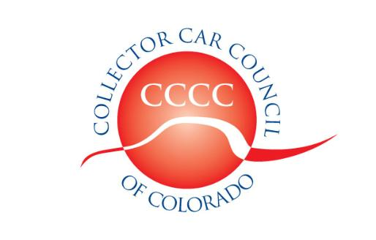

*Dedicated to the preservation of automotive history*

[**www.collectorcarcouncil.com**](http://www.collectorcarcouncil.com)

President: Dick Thompson, Denver Mustang Club 303-929-5533 Thompson660@cs.com

1st Vice Pres: John Ehrlich, ColoRODans 303-526-6805 Altechprec@yahoo.com

2nd Vice Pres: Calvin Craig, Colorado MOPAR Club 303-668-5142 CalvinCraig@msn.com

Secretary: Dick Fritz, MG Car Club 720-438-0191 RBFritz7@gmail.com

Treasurer: Tom Mansfield, Looking Glass Corvette 303-901-3562 tommans@outlook.com

Legislative information: Leo J. Boyle 303-321-6611 [Leojboyle@aol.com](mailto:Leojboyle@aol.com)

Political Committee Liaison: Dick Thompson 303-929-5533 Thompson660@cs.com

Web site liaison: Ben Aycrigg, RMR AACA 303-359-1350 [Baycrigg@Live.com](mailto:Baycrigg@Live.com)

RMMA Car Show & Swap Meet: Rick Ruel, Cobra Club 303-919-3760 rickrule@comcast.net

SEMA Show coordinator: John Ehrlich, ColoRODans 303-526-6805 [Altechprec@yahoo.com](mailto:Altechprec@yahoo.com)

Minutes of the 6 August 2025 Meeting

The meeting was held at the Forney Museum of Transportation 4303 Brighton Blvd., Denver, CO. 25 member-club representatives, one associate member, and one individual member were signed in. Officers present were Dick Thompson, president; Richard Fritz, secretary; and Tom Mansfield, Treasurer. The meeting was called to order at 7:30 pm.

**CCCC Vice Presidents:** Dick Thompson reported that both vie presidents are missing this evening because they suffered falls that left them injured.

**Legislation:** Leo Boyle advised that the special legislative session being called to deal with the state’s budget shortfall is limited by law to only with the budget issue, but we may see new “fees” attached to various issues that involve us as car owners. We have to wait and see.

**Friends of Collector Cars PAC:** The committee will not be issuing payments until we know which candidates are running in the next election.

The **minutes** of the July 2nd meeting were approved as published.

The **Treasurer’s Report** with a summary of accounts as of the end of July was presented and approved unanimously. 48 clubs are currently renewed.

**Mailing Lists:** The secretary noted that the mailing lists for CCCC minutes are dependent on information submitted on annual renewal forms and when new club officers are elected new names are added and old names may be dropped.

The **CCCC Car Show and Swap Meet** at the Broomfield Airport: The airport show had good weather and a good turnout. The efforts of organizers, volunteers, sponsors, airport staff, and venders were appreciated. A financial accounting has yet to be completed but the event seems to have done well.

**CCCC secretary and treasurer positions:** The CCCC Bylaws call for nominations for subsequent year officers to be made at the October regular meeting with election of officers to be held at the November meeting. Current secretary and treasurer officers have asked to be retired.

**Rods n’ Bodz:** The display is currently closed while they seek to find a permanent location which will be owned, not rented. There will be an auction of surplus memorabilia and vehicles on Aug.22 and 23 at 401 Englewood Parkway in Englewood.

**Forney Museum Dust n’ Shine events:** Dick Thompson listed the clubs that have signed up for the remaining months in 2025. Clubs should arrive at 9:30 am on their scheduled day and should provide in advance a list of volunteers. The CCCC is scheduled for September 20th.

**Forney Museum Sweepstakes:** The Forney Museum is holding a fund-raising sweepstake which will award a 2026 Chevrolet Corvette

**Saratoga Casino Blackhawk:** The Saratoga Casino in Blackhawk has offered to host a club car show and tour at their casino. The information, phone 303-582-6130 or 720-925-0728.

**Colorado SAAB Club:** Jim Beetham described the club of Swedish SAAB owners which has applied for Associate Membership in the CCCC. They had a display of six of their cars at the Airport Show.

The next meeting will be Tuesday, Sept. 2nd at Gateway Classic Cars, 14150 Grasslands Drive, Englewood. The change to Tuesday is to accommodate another group’s meeting on Wednesday

Meeting was adjourned at 8:27 pm.

Submitted by Richard Fritz, CCCC secretary *pro tem.*

A